**Classroom Assignment – Mahesh Bharambe**

1. Containers – Running Applications

**Q1. Run an Nginx Web Server**

Pull the image from Dockerhub registry .

**docker pull nginx:latest**

Run the nginx container from nginx:latest

**docker run -p 8080:80 --name nginx-cont nginx:latest**

Output

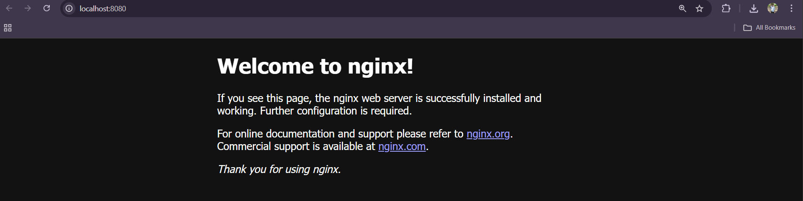

**--------------------------------------------------------------------------------------------------------------------------**

**Q2. Run a Python App inside a Container**

Pull the image from Dockerhub registry .

**docker pull python:3.10-slim**

Run the python container from python:3.10-slim

**docker run --name python-cont1 --rm python:3.10-slim python -c "print('Mahesh Bharambe')"**

Output

Mahesh Bharambe

**--------------------------------------------------------------------------------------------------------------------------**

**Q3. Run a MySQL Database**

Pull the image from Dockerhub registry .

**docker pull mysql:8**

Run the mysql container from mysql:8

**docker run --name mysql-cont -d -e MYSQL_ROOT_PASSWORD=root mysql:8**

Access the container shell

**docker exec -it mysql-cont /bin/bash**

To login in to Mysql

**mysql -uroot -p (Inside the bash)**

To show Databases

**SHOW DATABASES;**

Output

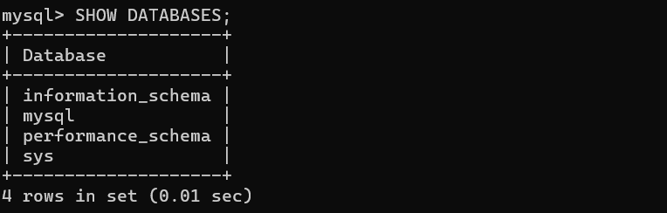

**--------------------------------------------------------------------------------------------------------------------------**

2. Custom Images – Build Your Own

**Q4. Build a Flask Application Image**

[**https://github.com/Maheshbharambe45/docker-hands-on/tree/main/Flask-app**](https://github.com/Maheshbharambe45/docker-hands-on/tree/main/Flask-app)

To build to image from dockerfile

**docker build -t python-img**

To run the container from python image

**docker run -d -p 5000:5000 --name flask-app python-img:latest**

Output



**--------------------------------------------------------------------------------------------------------------------------**

**Q5. Create a Custom Nginx Image**

[**https://github.com/Maheshbharambe45/docker-hands-on/tree/main/Nginx-server-docker**](https://github.com/Maheshbharambe45/docker-hands-on/tree/main/Nginx-server-docker)

To build to image from dockerfile

**docker build -t nginx-html .**

To run the container from nginx image

**docker run --name nginx-contt -d -p 5000:80 nginx-html**

Output

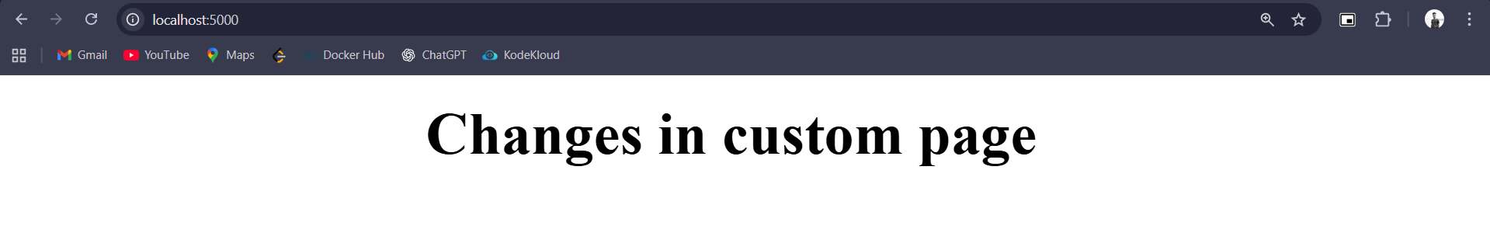

**--------------------------------------------------------------------------------------------------------------------------**

3. Volumes – Persisting Data

**Q6. WordPress with Persistent MySQL**

[**https://github.com/Maheshbharambe45/docker-hands-on/tree/main/wordpress-mysql-docker**](https://github.com/Maheshbharambe45/docker-hands-on/tree/main/wordpress-mysql-docker)

To run the containers

**docker compose up**

**output**

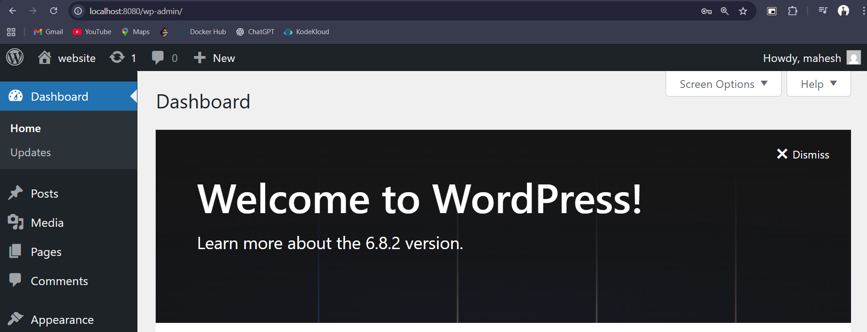

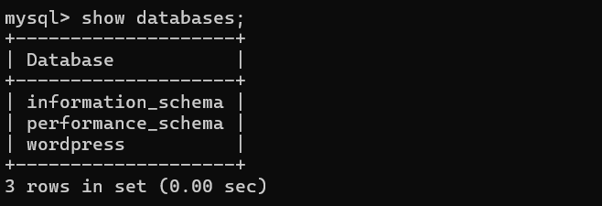

**--------------------------------------------------------------------------------------------------------------------------**

**Q7. Flask with Bind Mount**

[**https://github.com/Maheshbharambe45/docker-hands-on/tree/main/Flask-app**](https://github.com/Maheshbharambe45/docker-hands-on/tree/main/Flask-app)

To build to image from dockerfile

**docker build -t python-img .**

To run the container from python image

**docker run --name flask-app --rm -p 5000:5000 -v M:/docker-hands-on/Flask-app:/app flask-img:latest**

To check data is storing or not

**docker exec -it flask-app ls -la /app**

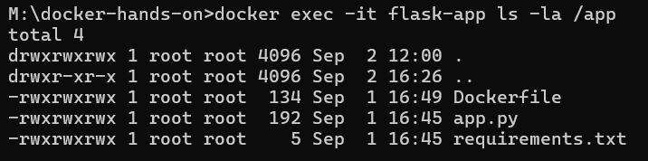

**--------------------------------------------------------------------------------------------------------------------------**

4. Networks – Multi-Container Applications

**Q8. Flask + Redis Counter App**

To run the containers of flask and redis

<https://github.com/Maheshbharambe45/docker-hands-on/tree/main/Flask-redis-docker>

To run the container

**docker compose up**

Output

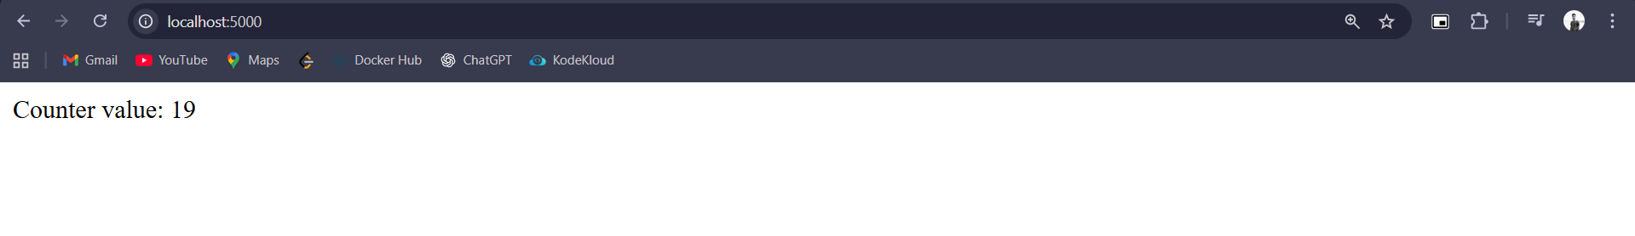

**--------------------------------------------------------------------------------------------------------------------------**

**Q9. MySQL + WordPress Blogging App**

To run the containers of mysql and wordpress

[**https://github.com/Maheshbharambe45/docker-hands-on/tree/main/wordpress-mysql-docker-network**](https://github.com/Maheshbharambe45/docker-hands-on/tree/main/wordpress-mysql-docker-network)

To run the container

**docker compose up**

To check both containers in same network

**docker network ls wordpress-mysql-docker-network**

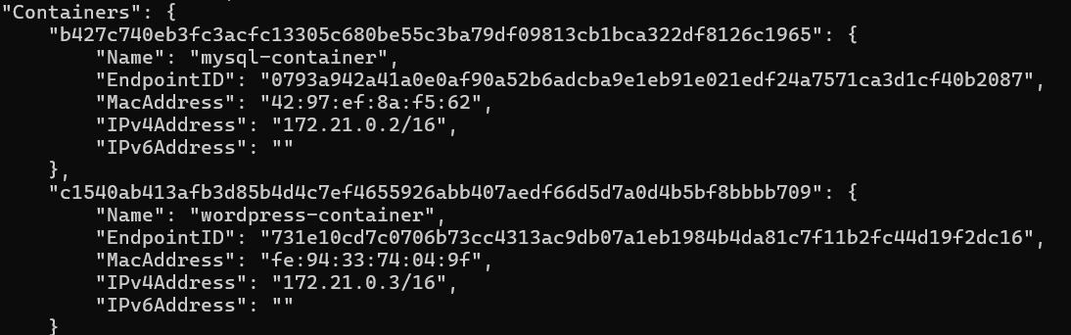

**--------------------------------------------------------------------------------------------------------------------------**

Docker Compose

**Q10. Convert Flask + Redis App into Docker Compose**

To run the containers of flask and redis

<https://github.com/Maheshbharambe45/docker-hands-on/tree/main/Flask-redis-docker>

To run the container

**docker compose up**

Output



**--------------------------------------------------------------------------------------------------------------------------**

**Q11. Node.js + MongoDB Full Stack Setup**

To run the node and MongoDB container

<https://github.com/Maheshbharambe45/docker-hands-on/tree/main/Nodejs-mongo-docker>

To run the container

**docker compose up**

Output

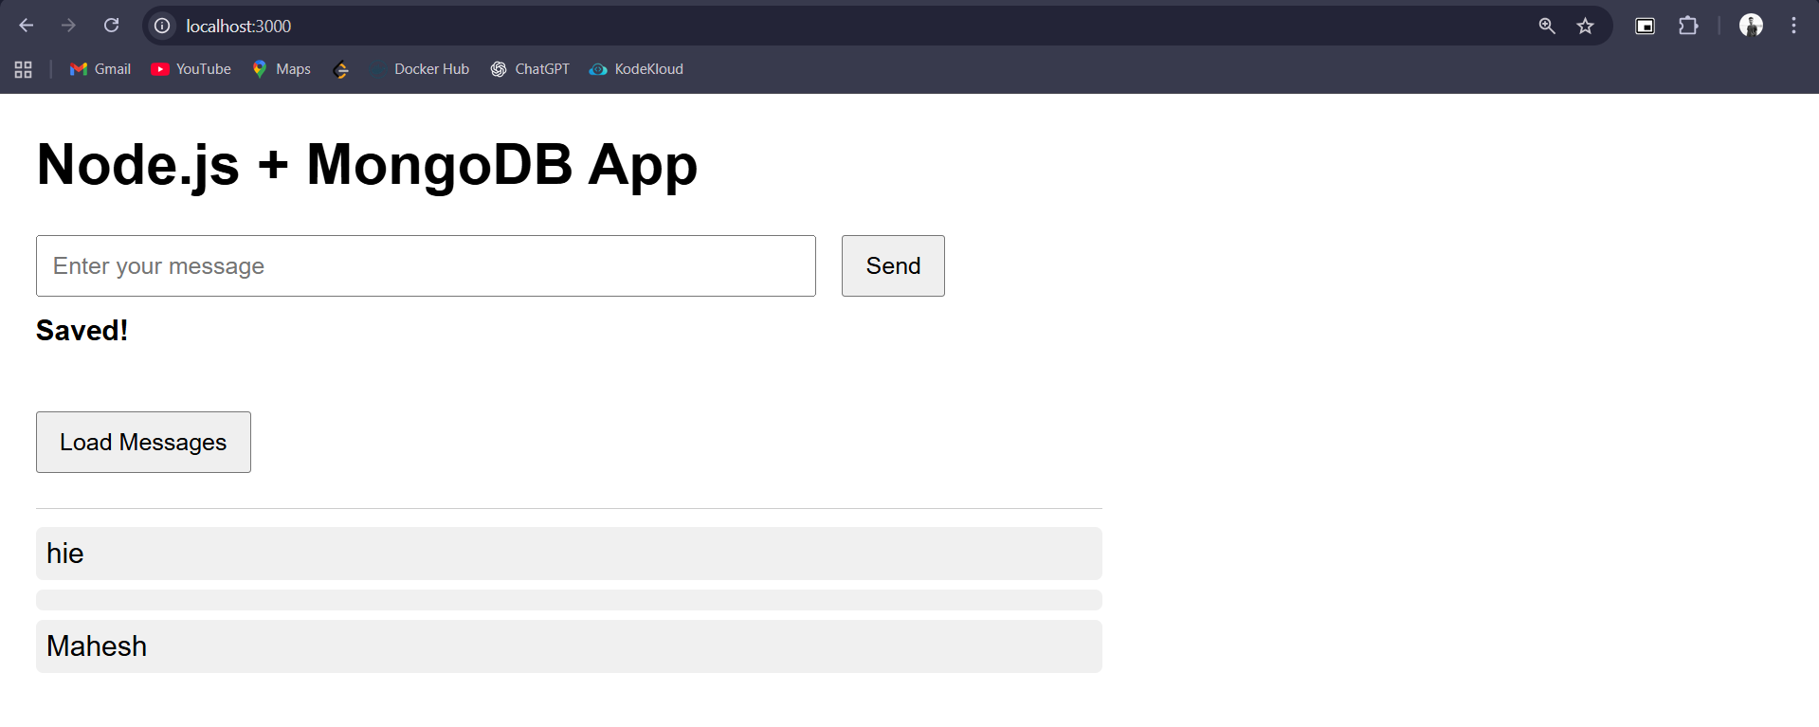

To show the networks

**docker network ls**

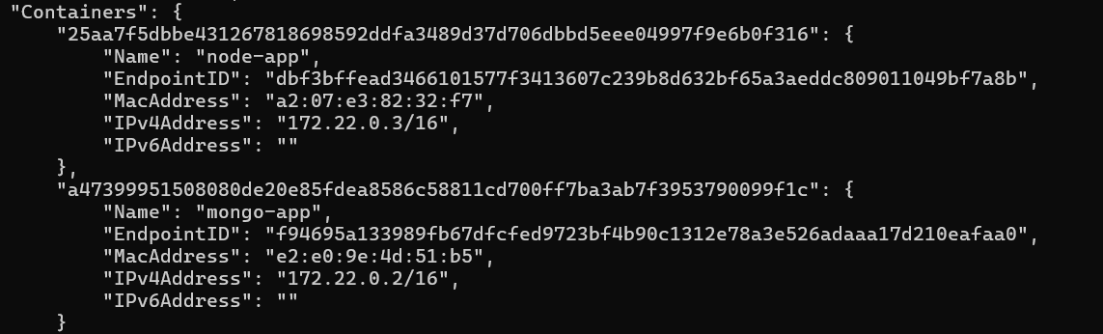

To show the volumes

docker container inspect node-app

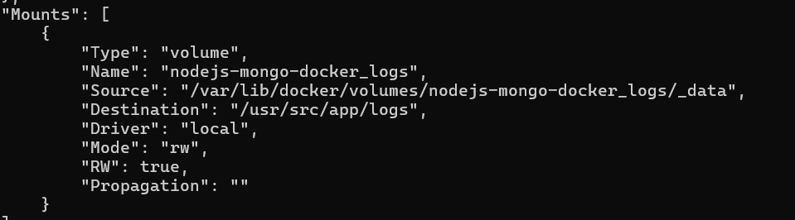

docker container inspect mongo-app



